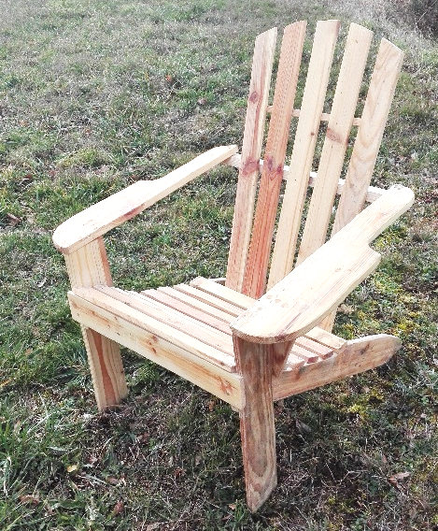
Ref : FAUTEUIL
Prix : 25.00 €
Atelier Bois-Mr POYET
Catalogue 2021
Ref : FAUTEUIL + REPOSE PIEDS
Prix : 30.00 €
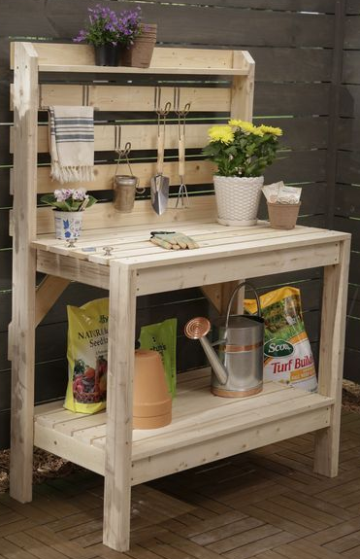
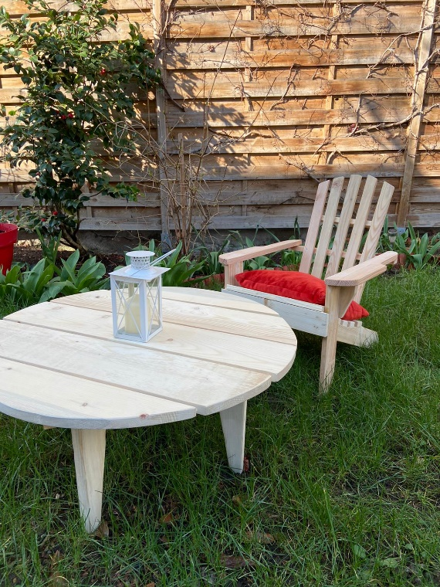
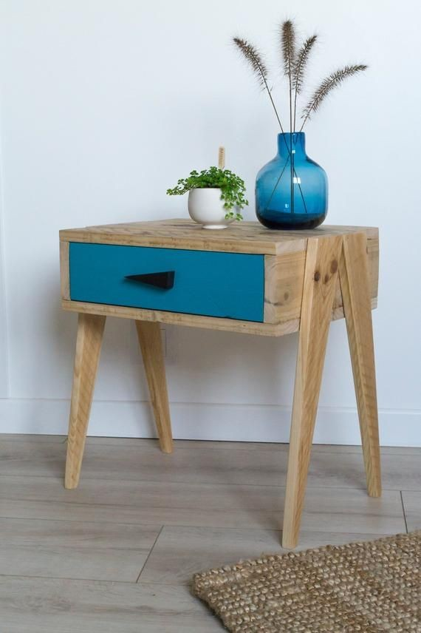
Ref : TABLE DE REMPOTAGE
Plan de travail : hauteur 90 cm largeur 1.20 m
Prix : 30.00 €
Le catalogue est aussi disponible sur notre blog :
https://blog.fondation-ove.fr/taron/
Ref : TABLE DE JARDIN
Prix : 15.00 €
Ref : FAUTEUIL ENFANT
Prix : 15.00 €
Ref : TABLETTE AVEC TIROIR
Prix : 15.00 €
Les articles sont en bois brut
(Ni vernis, ni peinture)
NOM: ________________________ PRENOM: ________________________ DATE: __/__/____
Désignation | Prix unitaire | Qté | Prix total
TOTAL
TEL: ________________

NOM: ________________________ PRENOM: ________________________ DATE: __/__/____
Désignation | Prix unitaire | Qté | Prix total
TOTAL
TEL: ________________

NOM: ________________________ PRENOM: ________________________ DATE: __/__/____
Désignation | Prix unitaire | Qté | Prix total
TOTAL
TEL: ________________

NOM: ________________________ PRENOM: ________________________ DATE: __/__/____
Désignation | Prix unitaire | Qté | Prix total
TOTAL
TEL: ________________

BONS DE COMMANDE

